Burpees

Plank

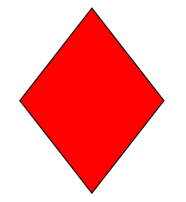

T-Planks

Pushups