Power Jacks

Mummy Kicks

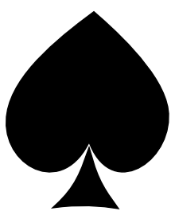

Jumping Jacks

Star Jumps